**Name:** Vishal Shashikant Salvi.

**Class**: SE Comps

**Batch:** C

**UID: 2019230069**

**Aim:**

Create a registration form and perform validation on click of submit button. If all required fields are not filled, use JavaScript to move the button & change text of button to catch me! Also create Tic Tac Toe game.

**Theory:**

**What is JavaScript?**

Java script is a dynamic computer programming language. It is lightweight and most commonly used as a part of web pages, whose implementations allow client-side script to interact with the user and make dynamic pages. It is an interpreted programming language with object-oriented capabilities. JavaScript was first known as Live Script, but Netscape changed its name to JavaScript, possibly because of the excitement being generated by Java. JavaScript made its first appearance in Netscape 2.0 in 1995 with the name Live Script. The general-purpose core of the language has been embedded in Netscape, Internet Explorer, and other web browsers. The ECMA-262 Specification defined a standard version of the core JavaScript language.

• JavaScript is a lightweight, interpreted programming language.

• Designed for creating network-centric applications.

• Complementary to and integrated with Java.

• Complementary to and integrated with HTML.

• Open and cross-platform.

**Client-Side JavaScript :**

Client-side JavaScript is the most common form of the language. The script should be included in or referenced by an HTML document for the code to be interpreted by the browser. It means that a web page need not be a static HTML, but can include programs that interact with the user, control the browser, and dynamically create HTML content. The JavaScript client-side mechanism provides many advantages over traditional CGI server-side scripts. For example, you might use JavaScript to check if the user has entered a valid e-mail address in a form field.

The JavaScript code is executed when the user submits the form, and only if all the entries are valid, they would be submitted to the Web Server.

JavaScript can be used to trap user-initiated events such as button clicks, link navigation, and other actions that the user initiates explicitly or implicitly.

**Advantages of JavaScript**

The merits of using JavaScript are:

• Less server interaction: You can validate user input before sending the page off to the server. This saves server traffic, which means less load on your server.

• Immediate feedback to the visitors: They don't have to wait for a page reload to see if they have forgotten to enter something.

• Increased interactivity: You can create interfaces that react when the user hovers over them with a mouse or activates them via the keyboard.

• Richer interfaces: You can use JavaScript to include such items as drag-and drop components and sliders to give a Rich Interface to your site visitors.

**Limitations of JavaScript**

We cannot treat JavaScript as a full-fledged programming language. It lacks the following important features:

• Client-side JavaScript does not allow the reading or writing of files. This has been kept for security reason.

• JavaScript cannot be used for networking applications because there is no such support available.

• JavaScript doesn't have any multithreading or multiprocessor capabilities.

Once again, JavaScript is a lightweight, interpreted programming language that allows you to build interactivity into otherwise static HTML pages.

**Client side javascript:**

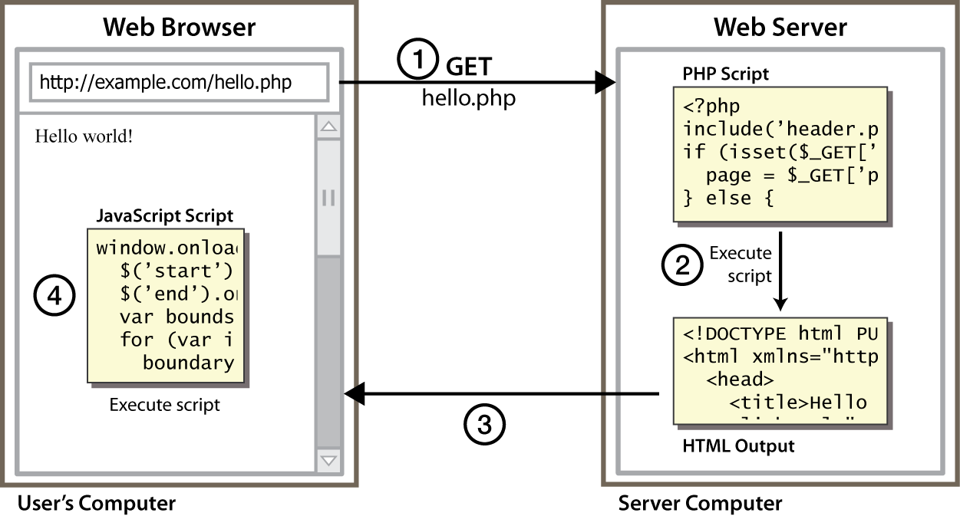

* client-side scripting (JavaScript) benefits:
  + usability: can modify a page without having to post back to the server (faster UI)
  + efficiency: can make small, quick changes to page without waiting for server
  + event-driven: can respond to user actions like clicks and key presses

**Code**:

<!DOCTYPE html> <style>

.cancel:hover {

font-size: 110%;

}

@import url('https://fonts.googleapis.com/css?family=Josefin+Sans&display=swap');

* {

margin: 0;

padding: 0;

box-sizing: border-box;

outline: none;

font-family: 'Josefin Sans', sans-serif

}

body {

background: cyan;

background size: cover;

height: 100vh

}

.wrapper {

 position: absolute;

top: 50%;

transform: translateY(-50%);

 width: 100%;

padding: 0 20px

}

.contact-form {

width: 80% ;

max width: 550px;

margin: 0 auto;

background: dodgerblue;

padding: 15px;

border : 5px ;

 display: flex;

box-shadow: 0 0 10px rgba(0, 0, 0, 0.13);

}

}

.input-fields, .optional-fields {

 width: 48%

}

.input, .optionalfields textarea {

margin: 10px 0;

background: transparent;

border: 0;

border bottom: 2px solid #c5ecfd;

padding: 10px;

color: #c5ecfd;

width: 100%

}

.optional-fields textarea {

height: 50px

}

::-webkit-input-placeholder {

color: black;

opacity: 0.5

}

::-moz-input-placeholder {

 color: black;

opacity: 0.5

}

::-ms-input-placeholder {

color: black;

opacity: 0.5

}

.button {

display: inline-block;

border-radius: 4px;

background color: dodgerblue;

border: none;

 color: red;

 text-align: center;

font size: 28px;

 padding: 10px;

 width: 150px;

transition: all 0.5s;

cursor: pointer;

margin: 5px

}

.button span {

cursor: pointer;

 display: inline-block;

position: relative;

transition: 0.5s

}

.button span:after {

 content: '\00bb';

position: absolute;

opacity: 0; top: 0;

right: -20px;

transition: 0.5s

}

.button:hover span {

 padding-right: 25px

}

.button:hover span:after {

opacity: 1;

right: 0

}

@media screen and (max-width:600px) {

.contact-form {

 flex-direction: column

}

.msg textarea {

 height: 80px

}

.input-fields, .msg {

 width: 100%

}

}

</style>

<script>

 function validate()

 {

var errorMessage = '';

if (!document.getElementById('name').value.match(/^[A-Z az]{1,50}$/))

 { if (document.getElementById('name').value.length > 50)

 {

errorMessage += 'Name cannot have more than 50 characters\n';

}

 } if(!document.getElementById('username').value.match(/^[A-Za-z]{1,50}$/))

{

if (document.getElementById('username').value.length > 50) { errorMessage += 'Username cannot have more than 50 characters\n';

} else {

errorMessage += 'Username cannot have digits or any other special characters\n';

}

}

 if (document.getElementById('password').value !==document.getElementById('confirmpassword').value)

 { errorMessage += 'Passwords do not match\n';

} if(!document.getElementById('email').value.match(/^\w+([\.-]?\w+)*@\w+([\.-]?\w+)*(\.\w{2,3})+$/))

 { errorMessage += 'Invalid email address\n';

}

 if (document.getElementById('email').value !==document.getElementById('confirmemail').value)

 { errorMessage += 'Emails do not match\n';

}

if (errorMessage.length != 0) { window.alert(errorMessage);

return false;

}

window.alert('Success');

return true;

}

function hoverEvent() {

if (document.getElementById('name').value == "" || document.getElementById('username').value == "" || document.getElementById('password').value == "" || document.getElementById('confirmpassword').value == "" ||document.getElementById('email').value == "" || document.getElementById('confirmemail').value == "")

 {

      document.getElementById("myBtn").style.position = "relative";

      var elem = document.getElementById("myBtn");

      elem.innerHTML = "Catch Me!";

 var pos = 0;

 var id = setInterval(frame, 1);

 function frame() {

 if (pos % 4 == 1) {

 clearInterval(id);

 } else {

 pos++;

elem.style.left = Math.floor(Math.random() * 800) + 'px'; elem.style.bottom =Math.floor(Math.random() * 400) +'px';

 }

 }

return false;

}

return true;

}

function keyPressEvent() {

 if (document.getElementById('name').value.length !=0 && document.getElementById('username').value.length != 0 && document.getElementById('password').value.length != 0 && document.getElementById('confirmpassword').value.length != 0 && document.getElementById('email').value.length != 0&&dcument.getElementById('confirmemail').value.length != 0)

 {

 var elem = document.getElementById("myBtn");

 elem.style.position = "static";

 elem.style.transform = "translateX(250px)";

 elem.innerHTML = "<span>Register </span>";

}

}

</script>

<html lang="en">

<head>

<meta charset="utf-8">

<title>Registration form</title>

</head>

<body>

<div class="wrapper">

<div class="contact-form">

<div class="input-fields">

 <div style="text-transform:uppercase;font-size: large;color: black"><b>User Registration</b></div>

<br>

 <p><span style="color: red;">*</span>

 <span style="color:black;"><b>Required Field</b></span></p>

<form action="#">

<input onkeydown="keyPressEvent()" type="text" id="name" class="input"placeholder="Name *">

<input onkeydown="keyPressEvent()" type="text" id="username" class="input" placeholder="Username *">

<input onkeydown="keyPressEvent()" type="password" id="password"class="input" placeholder="Password *">

<input onkeydown="keyPressEvent()" type="password" id="confirmpassword" class="input" placeholder="Confirm Password *">

<input onkeydown="keyPressEvent()" type="text" id="email" class="input"placeholder="Email Address *">

<input onkeydown="keyPressEvent()" type="text" id="confirmemail" class="input" placeholder="Confirm email Address *">

<span style="color:black;font size: smaller;">Date of Birth</span><input class="input" type="date" name="birthdate" value="DOB"><br>

<br><br>

</form>

<button id="myBtn" class="button" onmouseover="return hoverEvent()" onclick="return validate()" style="vertical align :middle ; transform: translateX(10px);">

    <span>Register</span></button>

</div>

<div class="optional-fields">

 <div style="text-transform:uppercase;font-size: large;color: black"><b>User Profile</b></div>

<br>

 <p><span style="color:black"><b>Optional Field</b></span></p>

 <input type="text" class="input"placeholder="Address 1 ">

 <input type="text" class="input"placeholder="Address 2 ">

<input type="text" class="input"placeholder="City ">

 <input type="text" class="input"placeholder="Region">

 <input type="text" class="input"placeholder="Country">

<input type="number" class="input" placeholder="Postal / ZIP Code">

<input type="tel" class="input" placeholder="Phone "pattern="[0-9]{1}[0-9]{1}[0-9]{10}">

 <input type="text" class="input"placeholder="Website ">

 <textarea placeholder="About me..."></textarea>

</div>

</div>

</div>

 </body> </html>

Output:

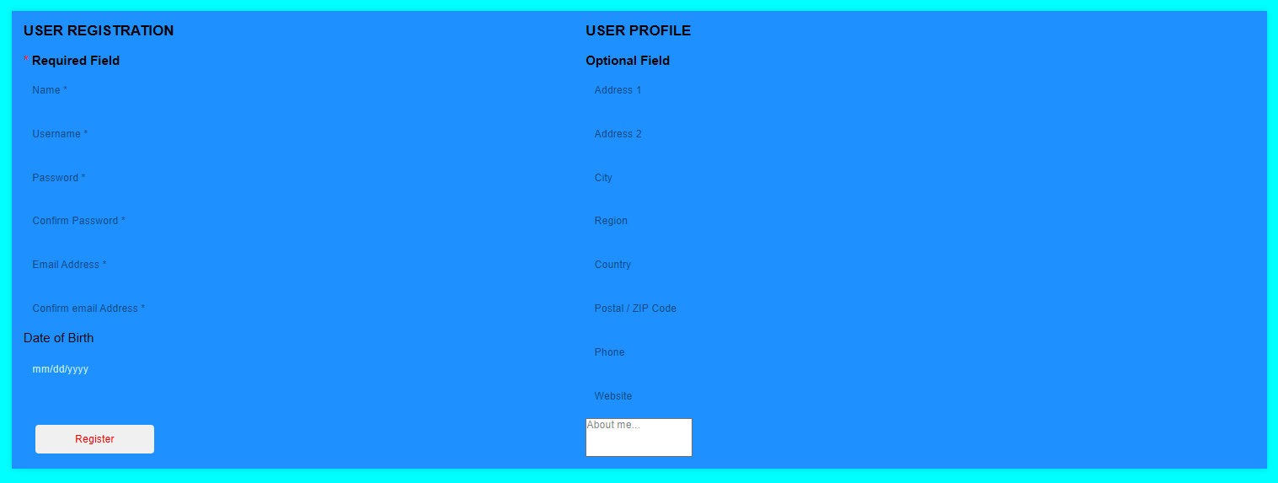

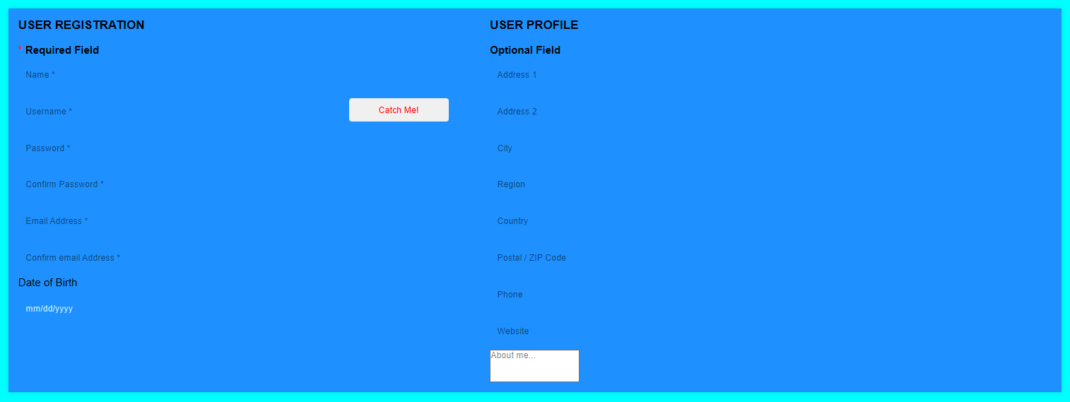

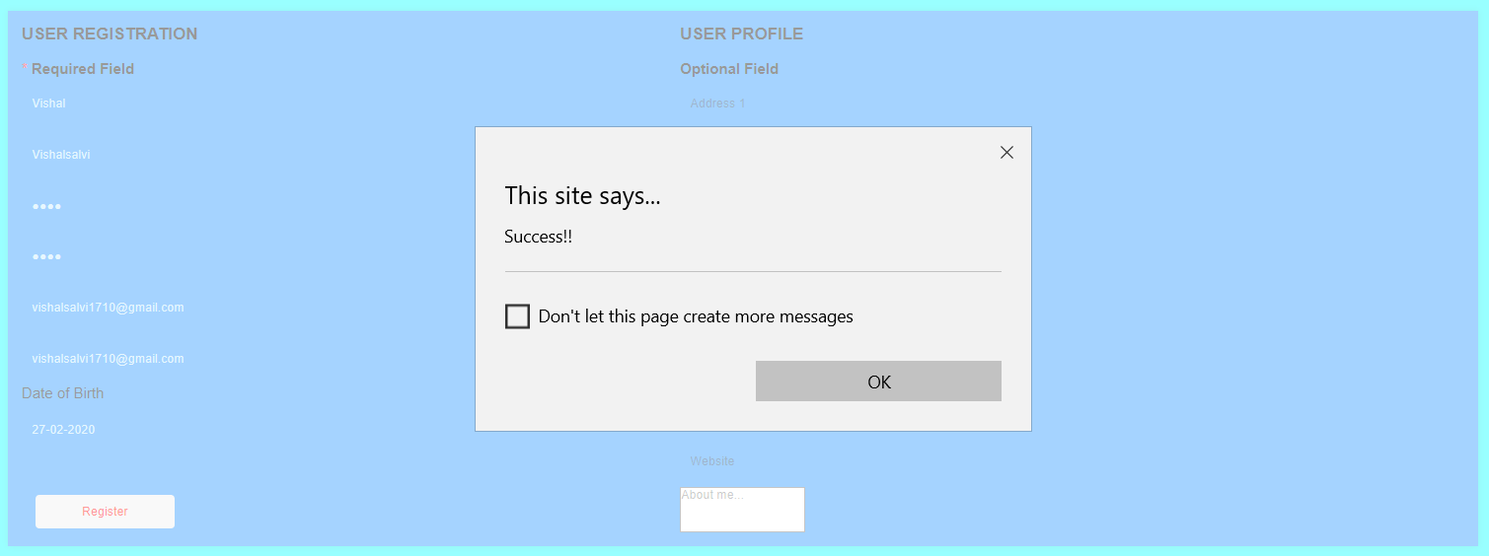

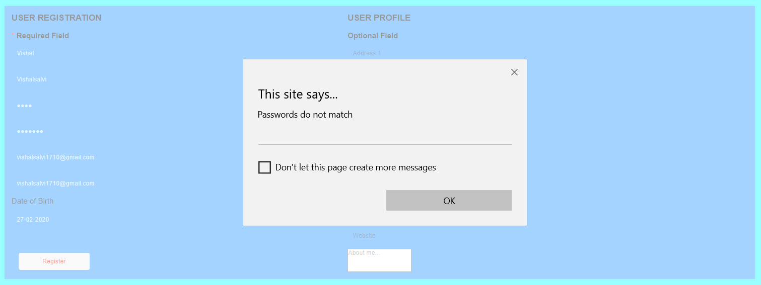

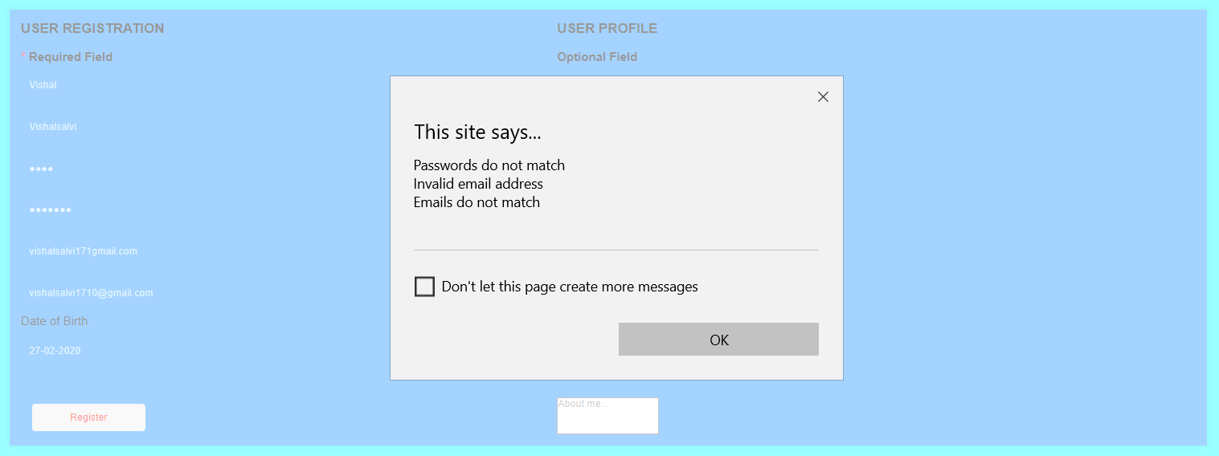

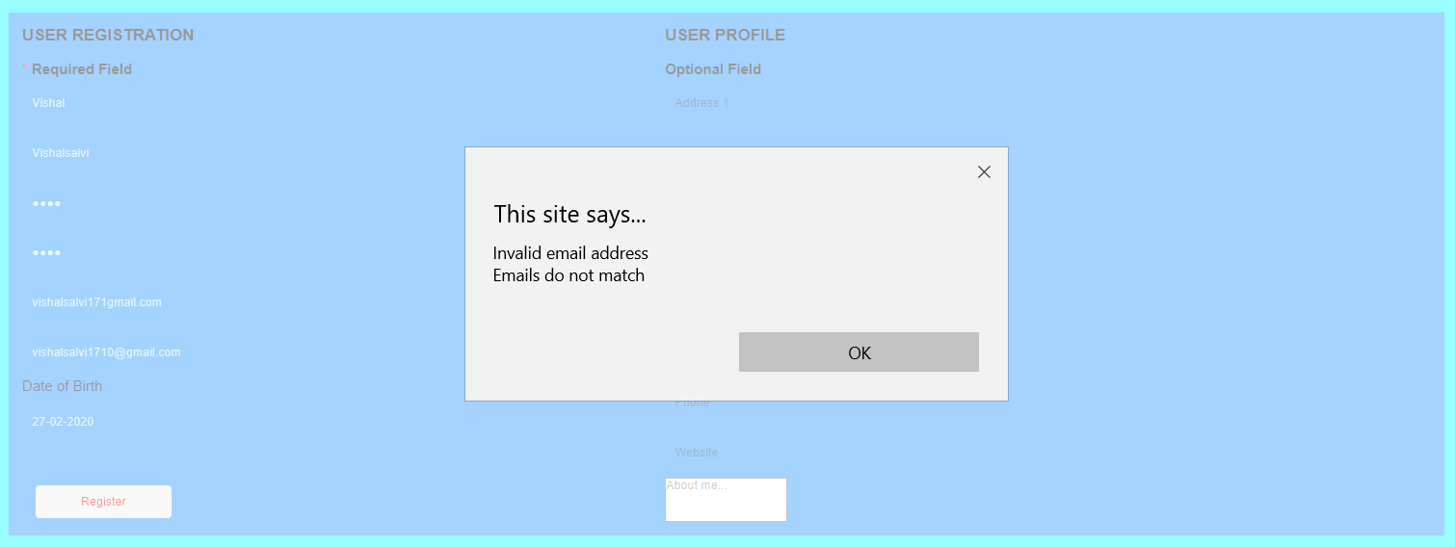

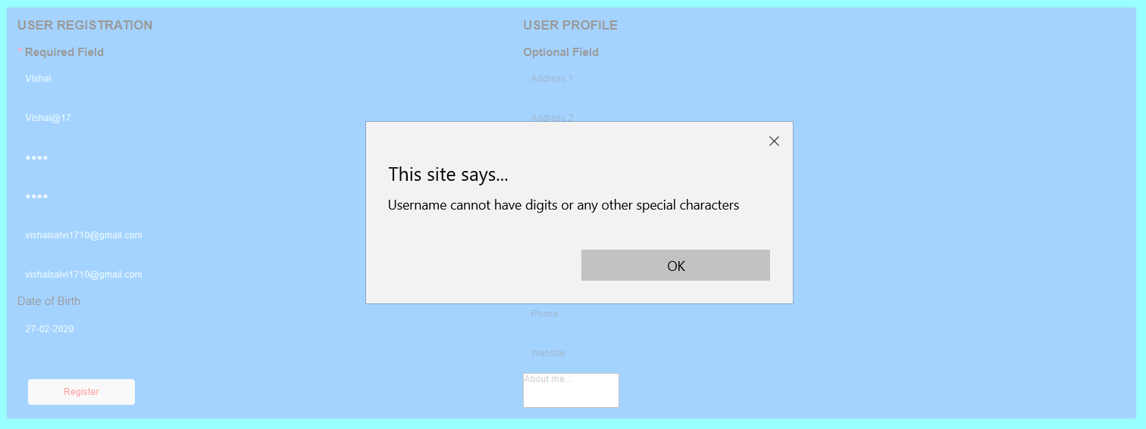

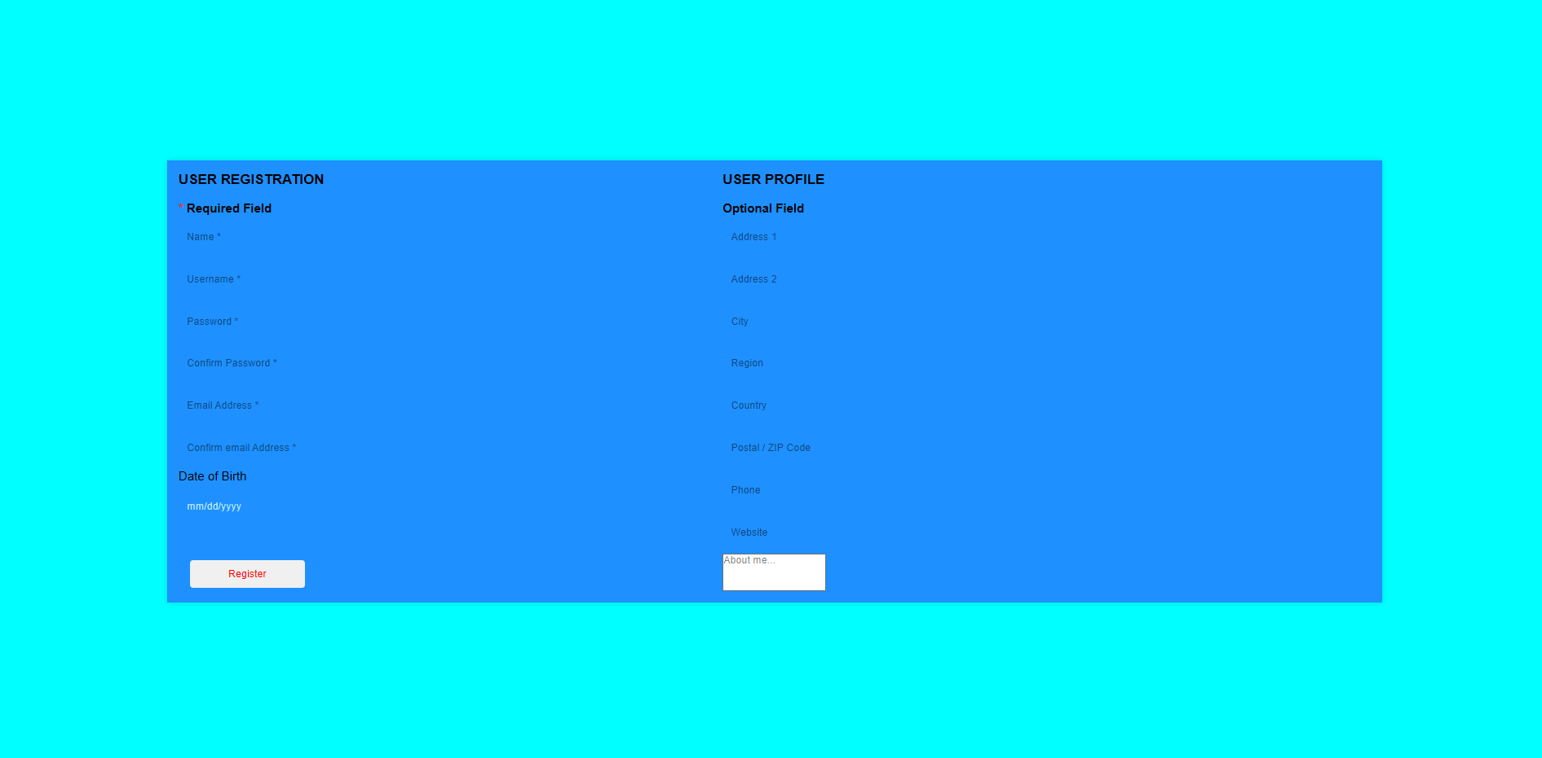

**Tic Tac Toe:**

**Code:**

<!DOCTYPE html>

<html>

<head>

<title>Tic Tac Toe </title>

<i><center><h1 style="color:blue;">If you know what you are doing, you can't lose at Tic-Tac-Toe....</h1>

<i><center><h2 style="color:blue;">If your opponent knows what they are doing, you can't win at Tic-Tac-Toe....</h2>

<i><center><h3 style="color:blue;">The game is a zero sum game....</h3>

<i><center><h4 style="color:blue;">If both players are playing with an optimal strategy, every game will end in a tie....</h4>

<style>

*{

box-sizing: border-box;

font-family: sans-serif;

}

body{

margin: 0;

padding: 0;

width: 100%;

height: 100vh;

display: flex;

justify-content: center;

align-items: center;

background-color: yellow;

}

.container{

width: 500px;

height: 500px;

position:bottom;

display: grid;

background-color: #1c4966;

grid-gap: 5px;

grid-template-columns: 33% 33% 33%;

grid-auto-rows: 33% 33% 33%;

}

.card{

position: relative;

background-color: orange;

cursor: pointer;

}

.card::before{

position: absolute;

top: 0; right: 0; bottom: 0; left: 0;

display: flex;

justify-content: center;

align-items: center;

font-weight: bold;

font-size: 8rem;

}

.card.x::before{

content: "X";

}

.card.o::before{

content: "O";

}

.winner{

display: flex;

flex-direction: column;

align-items: center;

justify-content: center;

position: fixed;

width: 600px;

height: 300px;

padding: 20px 40px;

background-color: #98FF98;

font-weight: bold;

font-size: 2rem;

border-radius: 20px;

text-align: center;

animation: animate .5s linear;

}

@keyframes animate{

from{

opacity: 0;

}

to{

opacity: 1;

}

}

.winner button{

margin-top: 40px;

width: 160px;

height: 70px;

line-height: 70px;

padding: 0;

border: 0;

outline: 0;

border-radius: 20px;

cursor: pointer;

color: #fff;

background-color:violet;

}

</style>

</head>

<body>

<div class="container">

<div class="card" data-index="1"></div>

<div class="card" data-index="2"></div>

<div class="card" data-index="3"></div>

<div class="card" data-index="4"></div>

<div class="card" data-index="5"></div>

<div class="card" data-index="6"></div>

<div class="card" data-index="7"></div>

<div class="card" data-index="8"></div>

<div class="card" data-index="9"></div>

</div>

</body>

<script>

const cards = Array.from(document.querySelectorAll(".card"));

const winner = [[1,2,3],[4,5,6],[7,8,9],[1,5,9],[3,5,7],[1,4,7],[2,5,8],[3,6,9

]];

let firstPlayer = [], secondPlayer = [], count = 0;

function check(array){

let finalResult = false;

for(let item of winner){

let res = item.every(val => array.indexOf(val) !== -1);

if(res){

finalResult = true;

break;

}

}

return finalResult;

}

function winnerpleyr(p){

const modal = document.createElement("div");

const player = document.createTextNode(p);

const replay = document.createElement("button");

modal.classList.add("winner");

modal.appendChild(player);

replay.appendChild(document.createTextNode("Play again?"));

// replay.setAttribute("onclick","rep();");

replay.onclick = function() { rep() };

modal.appendChild(replay);

document.body.appendChild(modal);

}

function draw(){

if(this.classList == "card"){

count++;

if(count%2 !== 0){

this.classList.add("x");

firstPlayer.push(Number(this.dataset.index));

if(check(firstPlayer)){

winnerpleyr("Congrats X player you win!!!!!");

return true;

}

} else{

this.classList.add("o");

secondPlayer.push(Number(this.dataset.index));

if(check(secondPlayer)){

winnerpleyr("Congrats O player you win!!!!!");

return true;

}

}

if(count === 9){

winnerpleyr("Oops..Its a Draw! Try again...... Better luck next time!");

}

}

}

function rep(){

const w = document.querySelector(".winner");

// cards.forEach(card => card.classList = "card");

firstPlayer = [];

secondPlayer = [];

count = 0;

w.remove();

[].forEach.call(cards, function(el) {

el.classList.remove("x");

el.classList.remove("o");

});

}

cards.forEach(card => card.addEventListener("click", draw));

</script>

</html>

**Output:**

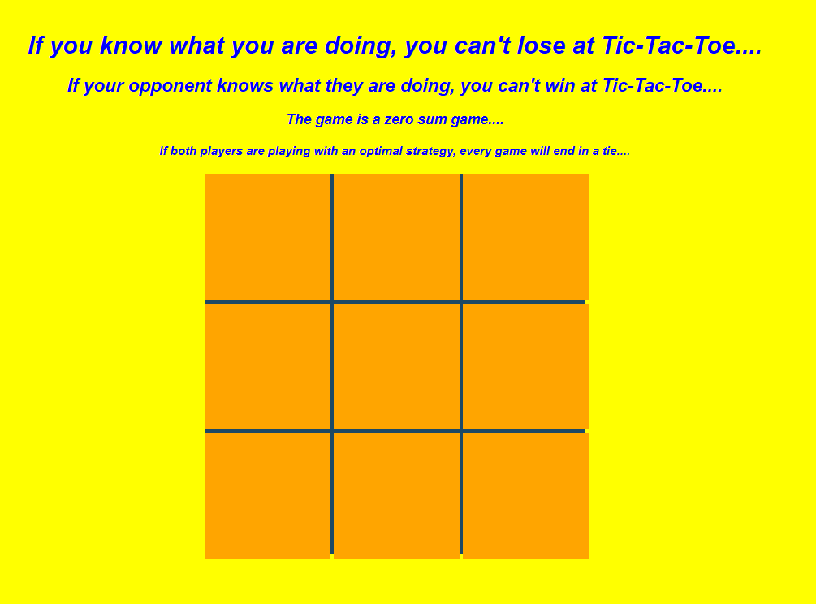

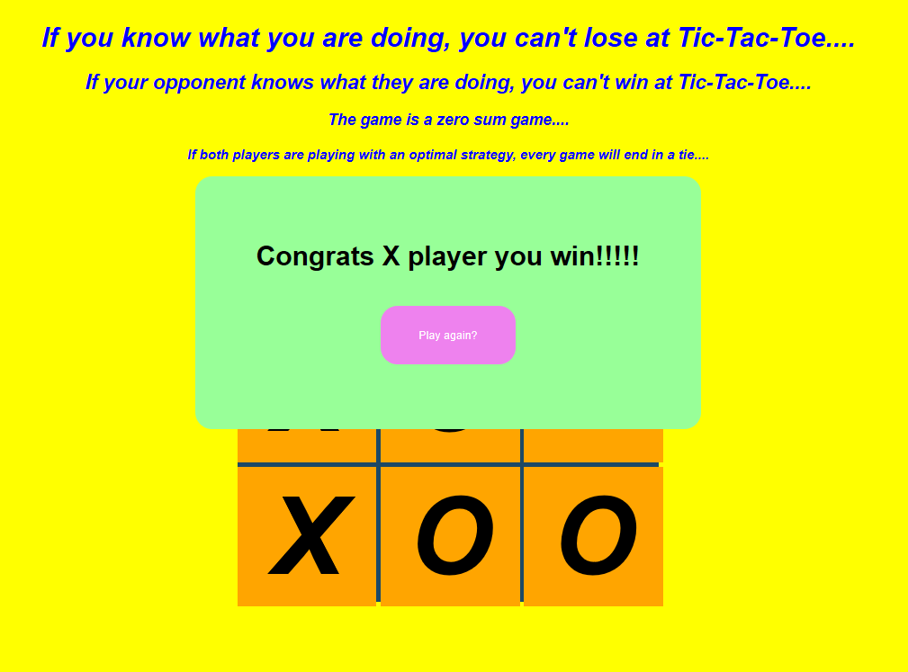

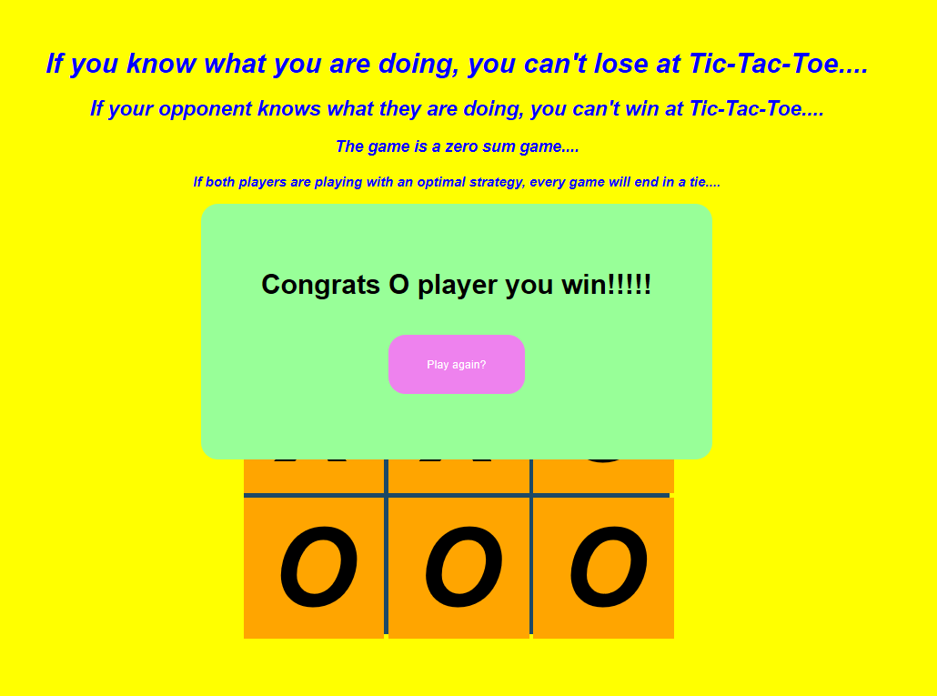

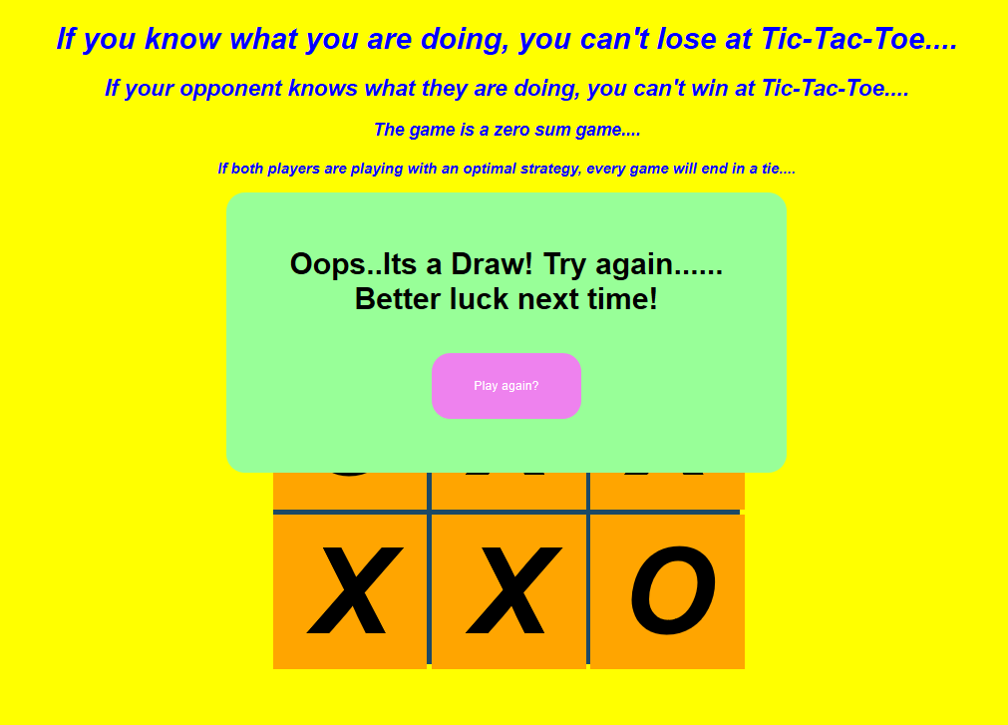

**Conclusion**:

1)JavaScript is a wonderful technology to use on the web. It is not that hard to learn and it is very versatile. It plays nicely with other web technologies such as HTML and CSS and can even interact with plugins such as Flash.

2)JavaScript allows us to build highly responsive user interfaces, prevent frustrating page reloads, and even fix support issues for CSS.

3)you can even use JavaScript to make online systems available offline and sync automatically once the computer goes online. JavaScript is also not restricted to browsers. The speed and small memory footprint of JavaScript in comparison to other languages brings up more and more uses for it from automating repetitive tasks in programs like Illustrator, up to using it as a server-side language with a standalone parser. The future is wide open.